

KG ERP USER MANUAL

**Prepared by: IT Department, Krishibid Group**

Content

Dashboard 2

**1.1 ERP Login Page** 2

1.2 ERP Home Page 3

1.2 Change Password 4

1. Employee 6

**2.1 Personal Information** 6

**2.2 Employees Contact Information** 7

**2.3 Anniversary Information** 8

2. Attendance 9

**2.1 Employee Attendance** 9

**2.2 Team Attendance** 10

**2.3 Time Approval Request** 11

2.3.1 Attendance Modify 11

2.3.2 On Field Duty 11

**2.4 Time Approval History** 12

**2.5** **Manager Time Approval** 13

**2.5 HR Admin Time Approval** 13

3. Leave 14

**4.1 Leave Balance** 14

**4.2 Leave History** 14

**4.3 Apply Leave** 15

**4.4 Manager Leave Approval** 16

**3.5** **HR Admin Leave Approval** 17

# Dashboard

## **1.1 ERP Login Page**

Go to ERP web application Login Page. URL: ([http://192.168.0.7:90](http://192.168.0.7:90/)/) the following figure shows the ERP Login page.

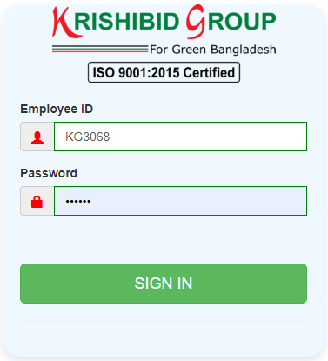

**Figure: 01 ERP Login**

Logging on ERP System:

* **Step-1:** Provide Valid **Username and Password. For Username Always Provide your Employee ID. (Example: EmployeeID : KGxxx , Password: KGxxxx)**
* **Step-2:** Click on **‘Sign In’** button for go to Home page of ERP.

# 1.2 ERP Home Page

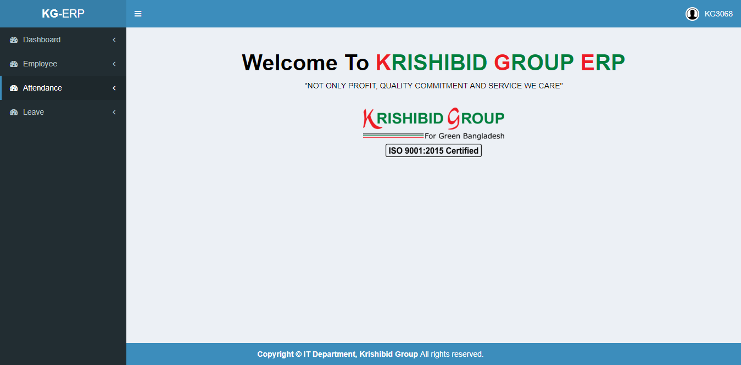The following figure (Fig-02) shows menu bar and home page.

**Figure: 02 ERP Home Page**

* **Step-01:** Click on the Dashboard section under main navigation panel of KG ERP.

# 1.2 Change Password

**Figure: 03 Employees Password Change Page (1)**

* **Step-01:** Click on the **Employee ID (KGxxxx)** section under main navigation panel of KG ERP.
* **Step-02:** Click on “**Change Password**” button for changed employee’s password.

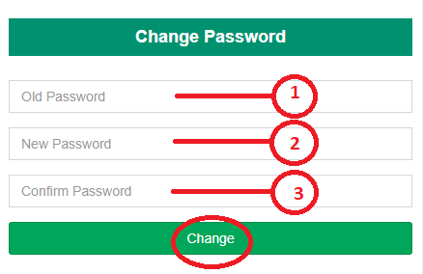

**Figure: 04 Employees Password Change Page (2)**

* **Step-02:** Enter “**Old Password**”, “**New Password**” and “**Confirm Password**” and click on “**Change**” button for changed employee’s current password and new password will be automatically generated. After logout from the ERP employee must enter updated password for entry on ERP.

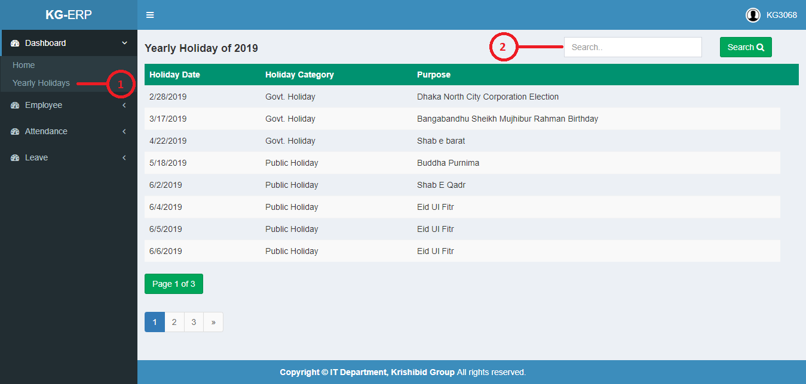The following figure (Fig-05) shows options for Yearly Holiday.

**Figure: 05 Yearly Holiday**

* **Step-01:** Click on the **Yearly Holiday** section under **Dashboard Menu** option. The following figure (Fig-05) shows the **Employees Yearly Holiday of Every year** page.
* **Step-02:** Enter any **“Date” or “Category” or “Purpose”** in the search section and click “Enter” button to search any holiday.

# Employee

## **2.1 Personal Information**

**Fig: 06 Employee Personal Info**

* **Step-01:** Click on the **Personal Information** section under **Employee Menu** option. The following figure (Fig-06) shows the Employees information based on personal Details and Service Details page.

## **2.2 Employees Contact Information**

**Fig: 07 Employee Contact Info**

* **Step-01:** Click on the **KG** **Contact Information** section under **Employee** **Menu** option. The following figure (Fig-07) shows the Employees information based on all necessary elements for any employee.
* **Step-02:** Enter any **“ID” or “Name” or “Department” or “Designation” or “Email”, “PBX No”, “Mobile No”, “Blood Group”** in the search section and click “Enter” button to search any employee.

## **2.3 Anniversary Information**

**Fig: 08 Anniversary Info**

* **Step-01:** Click on the **Anniversary** section under **Employee** **Menu** option. The following figure (Fig-08) shows the **KG** **Employees Birth and Work Anniversary Information**.
* **Step-02:** Enter any **“Anniversary” or “Event Date” or “Name” or “Department” or “Designation” or “Email”, “PBX No”, “Mobile No”, “Blood Group”** in the search section and click “Enter” button to search any employee.

# Attendance

## **2.1 Employee Attendance**

**Fig: 09 Employee Attendance Info**

* **Step-01:** Click on the **Employee Attendance** section under **Attendance Menu** option. The following figure (Fig-09) shows the Employees information based on all necessary elements for any employee.
* **Step-02:** Enter **“From Date” and “To Date”** forthe date section and click “Enter” button to search any employees attendance based on date range wise attendance.

## **2.2 Team Attendance**

**Fig: 10 Employee Attendance Info**

* **Step-01:** Click on the **Team Attendance** section under **Attendance Menu** option. The following figure (Fig-10) shows the Employees Team information based on **“In Time”** and “**Out Time”**.
* **Step-02:** Enter **“Date”** forthe date section and click “Enter” button. Line Manager can search any employees attendance based on date wise attendance value.

## **2.3 Time Approval Request**

### 2.3.1 Attendance Modify

**Fig: 11.1 Time Approval Request (Attendance Modify)**

* **Step-01:** Click on the **Time Approval Request** section under **Attendance** Menu option for Apply any request for time approval.
* **Step-02:** Enter **“Date”, “Application For”, Actual In Time, Actual Out Time (If needed) and “Reason”** forthe required section and click “**Request**” button for sending any modification to **Line Manager** for Approval request.

### 2.3.2 On Field Duty

**Fig: 11.2 Time Approval Request (On Field Duty)**

* **Step-01:** Click on the **Time Approval Request** section under **Attendance** Menu option.
* **Step-02:** Enter **“Date”, “Application For” and “Reason”** forthe required section and click “**Request**” button for sending any modification to **Line Manager** for Approval request.

## **2.4 Time Approval History**

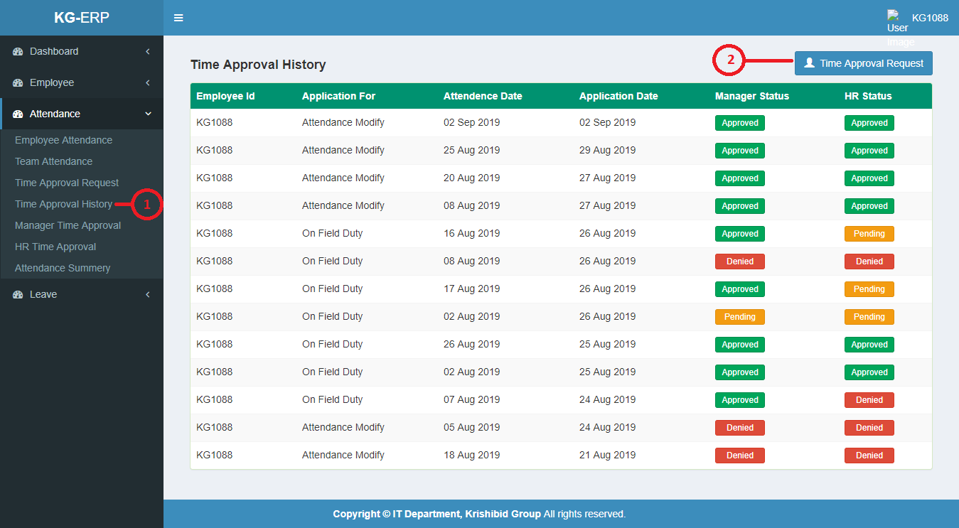**Fig: 12 Time Approval History**

* **Step-01:** Click on the **Time Approval History** section under **Attendance** Menu option and show the history data of applied any **Time Approval Request.**
* **Step-02:** User can apply any “**Time Approval Request”** by click on time Approval request button. The following figure (Fig-12) shows the Employees Time Approval Entry page.

## **Manager Time Approval**

**Fig: 13 Manager Time Approval**

* **Step-01:** Click on the **Manager** **Time Approval** section under **Attendance** Menu option and show the Managers awaiting Approval page. If Line manager approved or denied the application user can see their status will be updated.

## **2.5 HR Admin Time Approval**

**Fig: 14 HR Admin Time Approval**

* **Step-01:** Click on the **HR** **Time Approval** section under **Attendance** Menu option and show the HR awaiting Approval page. If Line manager approved or denied the application user can see their status will be updated.

# Leave

## **4.1 Leave Balance**

**Fig: 15 Leave Balance**

* **Step-01:** Click on the **Leave Balance** section under **Leave** Menu option and show the Employees Yearly Leave Balance Status page.

## **4.2 Leave History**

**Fig: 16 Leave Balance**

* **Step-01:** Click on the **Leave History** section under **Leave** Menu option and show the Employees Leave Applications History and Approved and Denied Status.
* **Step-02:** Enter **“Employee ID” or “Leave Category” or “Application Date” or “Start Date” or “End Date” or “Leave Days” or “Manager Status” or “HR Status”** forthe Search section and click “Enter” on button. Employee can search employees leave history based on search wise value.
* **Step-03:**  Click on “Apply Leave” button for applies for new leave. Show the fig(17) page.

## **4.3 Apply Leave**

**Fig: 17 Leave Balance**

* **Step-01:** Click on the **Apply** **Leave** section under **Leave** Menu option and show the Employees Leave Bonus and Employees can see their leave status and Applied for new leave.
* **Step-02:** Enter **“Leave Category”, “Start Date”, and “End Date”, “Stay during leave”, “Reason” and “Reason** forthe required section and click **“Submit”** button to apply new Leave.

## **4.4 Manager Leave Approval**

**Fig: 18 Manager Leave Approval (for Before Consuming Leave)**

* **Step-01:** Click on the **Manager** **Leave Approval** section under **Leave** Menu option and show the Employees Reporting Persons (Line Manager) Leave Approval Action Page and Line Manager can see employees Applied leave status.
* **Step-02:** If Manager Click on button for Approved Employees Applied Leave Approval.

**Note:** **If Employee applied any leave application before consuming the Leave then in this case, if line manager approved the application, HR Admin status will be automatically approved and updated.**

* 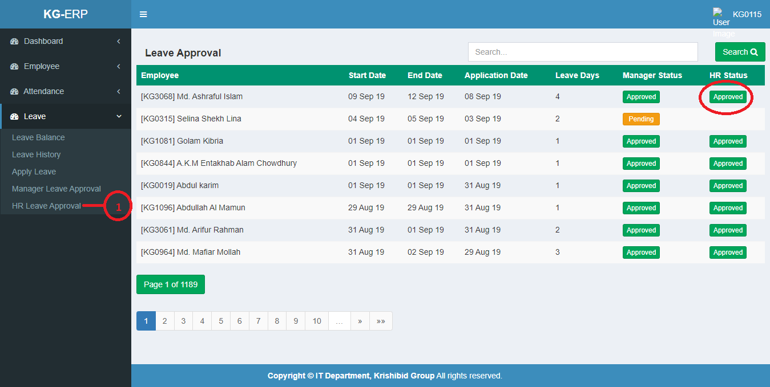**Step-03:** If Manager Click on button for Denied Employees Applied Leave. In this case manager must mention the reason for denied the application.

**Fig: 19 HR Admin Leave Approval (for Before Consuming Leave)**

* **Step-04:** HR Admin only can see the status for Employees Approved Leave Approval status from Line manager.

## **HR Admin Leave Approval**

**Fig: 20 Manager Leave Approval (for After Consuming Leave)**

* **Step-01:** Click on the **HR Admin** **Leave Approval** section under **Leave** Menu option and show the Employees Reporting Persons (Line Manager) Leave Approval Action Page and Line Manager can see employees Applied leave status.

**Note:** **If Employee applied any leave application after consuming the Leave then in this case, if line manager approved the application, HR Admin status will won’t be automatically approved and updated. If HR Admin approved the application employees can see their updated status. That leave will be approved on that time. Otherwise If HR Admin Denied the application then must mention the reason and Employees consuming leave will be denied.**

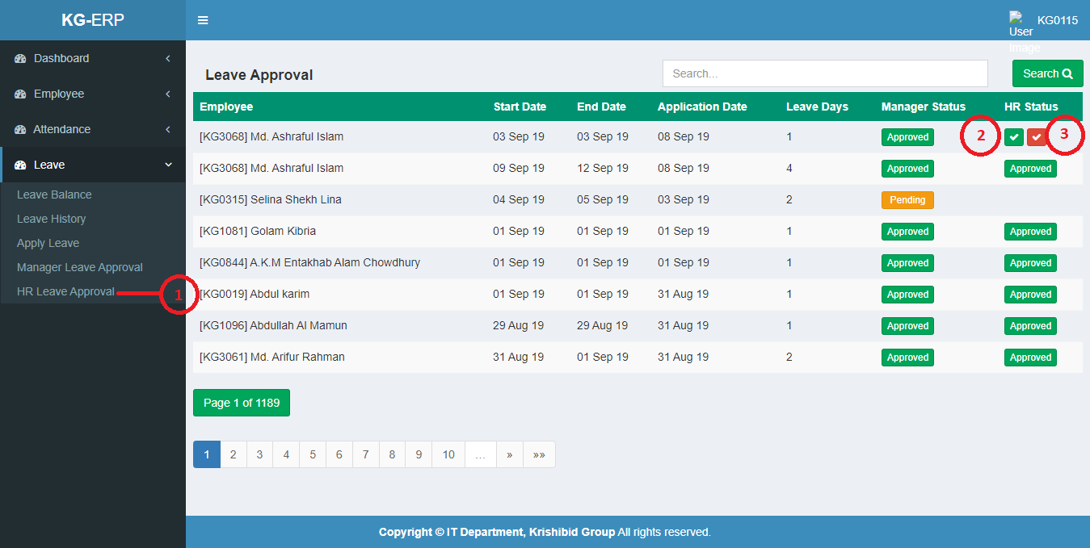 **Fig: 21 HR Admin Leave Approval (for After Consuming Leave)**

* **Step-02:** If HR Admin Approved the application employees can see their updated status. That leave will be approved on that time.
* **Step-03:** Otherwise If HR Admin Denied the application then must mention the reason and Employees consuming leave will be denied.